**Task 3- Event Mangement System using PostgreSQL**

**1.Database Creation**

create database EventsManagement;

create table Events (

Event_Id INT Primary Key,

Event_name text,

Event_date date,

Event_location text,

Event_description text);

create table Attendees(

Attendee_Id INT Primary Key,

Attendee_name text,

Attendee_Phone NUMERIC,

Attendee_email text,

Attendee_city text);

Create table Registrations(

Registration_Id INT Primary Key,

Event_ID INT,

Attendee_Id INT,

Registration_date date,

Registration_amount numeric,

FOREIGN Key(Event_Id) references events(event_Id),

FOREIGN Key(Registration_Id) references Registrations(Registration_Id));

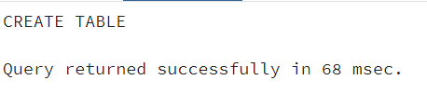

**2. Data Creation** **insert into events values**

--inserting values into events table

(101,'Moonlight','2022-11-12','Bilaspur','Once in a lifetime'),

(102,'Jio','2022-11-13','Jammu','Jio Dhan Dhanadhan'),

(103,'Verasity','2022-11-14','Lahore','Vampire university'),

(104,'Zukebox','2022-11-15','Madurai','Box in a tempo'),

(105,'RJ Raveena','2022-11-16','Trichy','Raveena Kareena and Tareena');

--Inserting values into attendees table

insert into Attendees values (601,'Krishna','8973772165','Krishna@amazon.com','Tripura'),

(602,'Abha','9876543211','abha@amazon.com','Delhi'),

(603,'Rahul','9600652234','rahul@amazon.com','Mumbai'),

(604,'Yash','9988776655','yash@amazon.com','Madurai'),

(605,'Saba','8899007766','saba@amazon.com','Kashmir');

--Inserting values into Registrations table

insert into registrations values (901,101,601,'2022-10-10','9000'),

(902,102,602,'2022-10-11','11200'),

(903,103,603,'2022-10-12','71200'),

(904,104,604,'2022-11-13','7500'),

(905,105,605,'2022-10-13','14230');

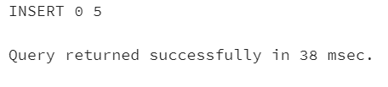

**3. Manage event details**

**(a)** **Inserting a new event**

insert into events (Event_id,Event_name,Event_date,Event_location,Event_description) values

('106','Rickash','2022-11-18','Kohlapur','Dil Jahan aur aap');

**(b)Update existing event**

Update events set event_name='Titan Tornado' where Event_id='104';

**(c)Delete existing event**

delete from registrations where Event_id='104';

delete from events where Event_id='104';

**4.Manage Track Attendees & Handle Events**

**(a) Inserting a new attendee**

Insert into attendees (Attendee_id,Attendee_name,Attendee_phone,Attendee_email,Attendee_city) values

(606,'koyla','147563892','koyla@amazon.com','mysore');

**(b) Registering an attendee for an event**

insert into registrations (Registration_id,Event_id,Attendee_id,Registration_date,Registration_amount) values

(906,105,006,'2022-12-05','40000');

**5.Query to retrieve event information**

Select * from events_table;

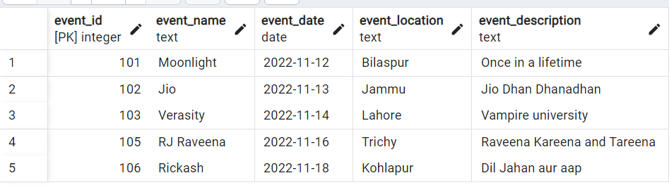

**Query to generate attendee lists**

Select attendee_name from attendees;

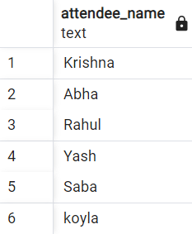

**Query to calculate event attendance statistics**

select events.event_name,count(registrations.attendee_Id)as No_of_attendees

from registrations

left join events on events.event_Id= registrations.event_id

group by 1;

